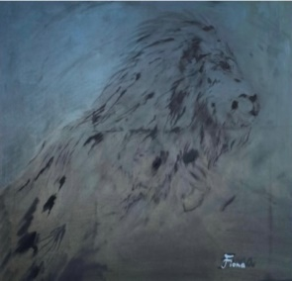 | 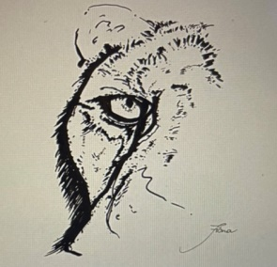 | 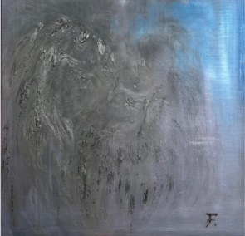 | 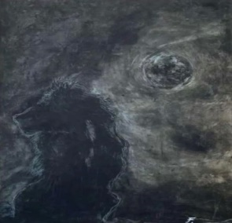
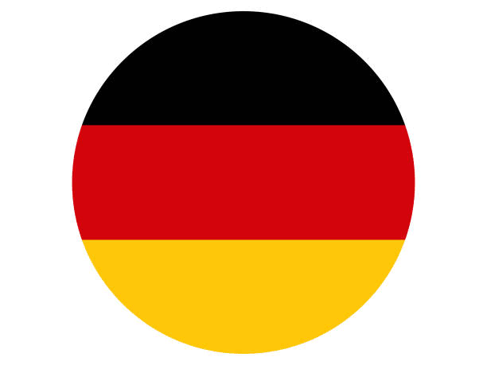 |  |  | 
(Ausgewählt)  July 2023 | (Selected award )  Augst 2023 | (Selected award )  Sepmber2023 | (6th Place )  Octmber 2023
Dream  80x60cm  Oil Painting on  canvas | Lion-2  23x35cm  Marker on paper | Lion-17  52x45cm  Oil Painting on canvas | Lion-9  80x65cm  Oil Painting on  canvas
2023 Kyla Artist Prize | The first Grey  Art Competition | 6th Annual Women | 2023 ALMIERICAN  ART Award
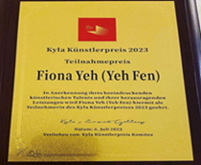 | 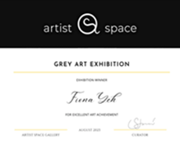 |  | 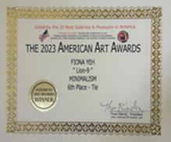

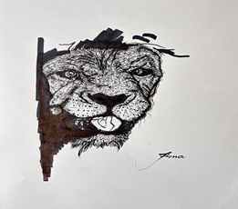 | 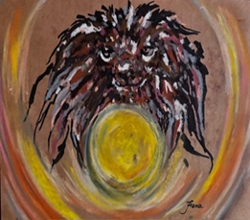 | 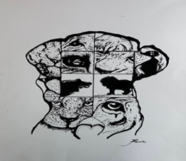
 | 
SpecialRecognition)  January 2024 | (First Place)  March 2024
Lion BK-26  34x25cm  Marker on paper | Lion-12  21X29.7cm  Oil painting crayons, markers on paper | LionBW-66  42X29.7cm  Marker on paper
13th Annual  All Women Award | 2024 KYLA Illustration  Artist Prize
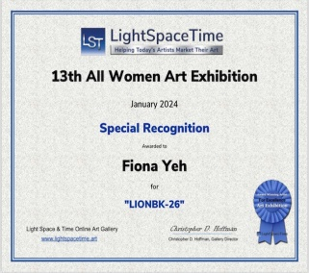 | 